

Lab # 05

Web Engineering Fall 2020



Instructor | Mr. Safder Ali
Student Name | Hamad Ali Shah
CMSID | 454591
Department | BS-CS-23
Semester | 5th semester

PRELAB WRITING ASSIGNMENT
Fill in the blanks | - Media queries are used in to create styles for specific device types or screen sizes.  - A 12-column grid system is often used in web development to create and layouts.  - Media queries use to apply different styles based on the width of the device or screen.  - In a 12-column grid system, each column takes up a  of the total available space, usually 1/12 or 2/12.  - The classes in a 12-column grid system allow you to shift columns to the right, creating space between them.

Lab 5.2 | Lab Tasks

1. Update your Resume web page with 12-Column grid concept.

Desktop screenshot:
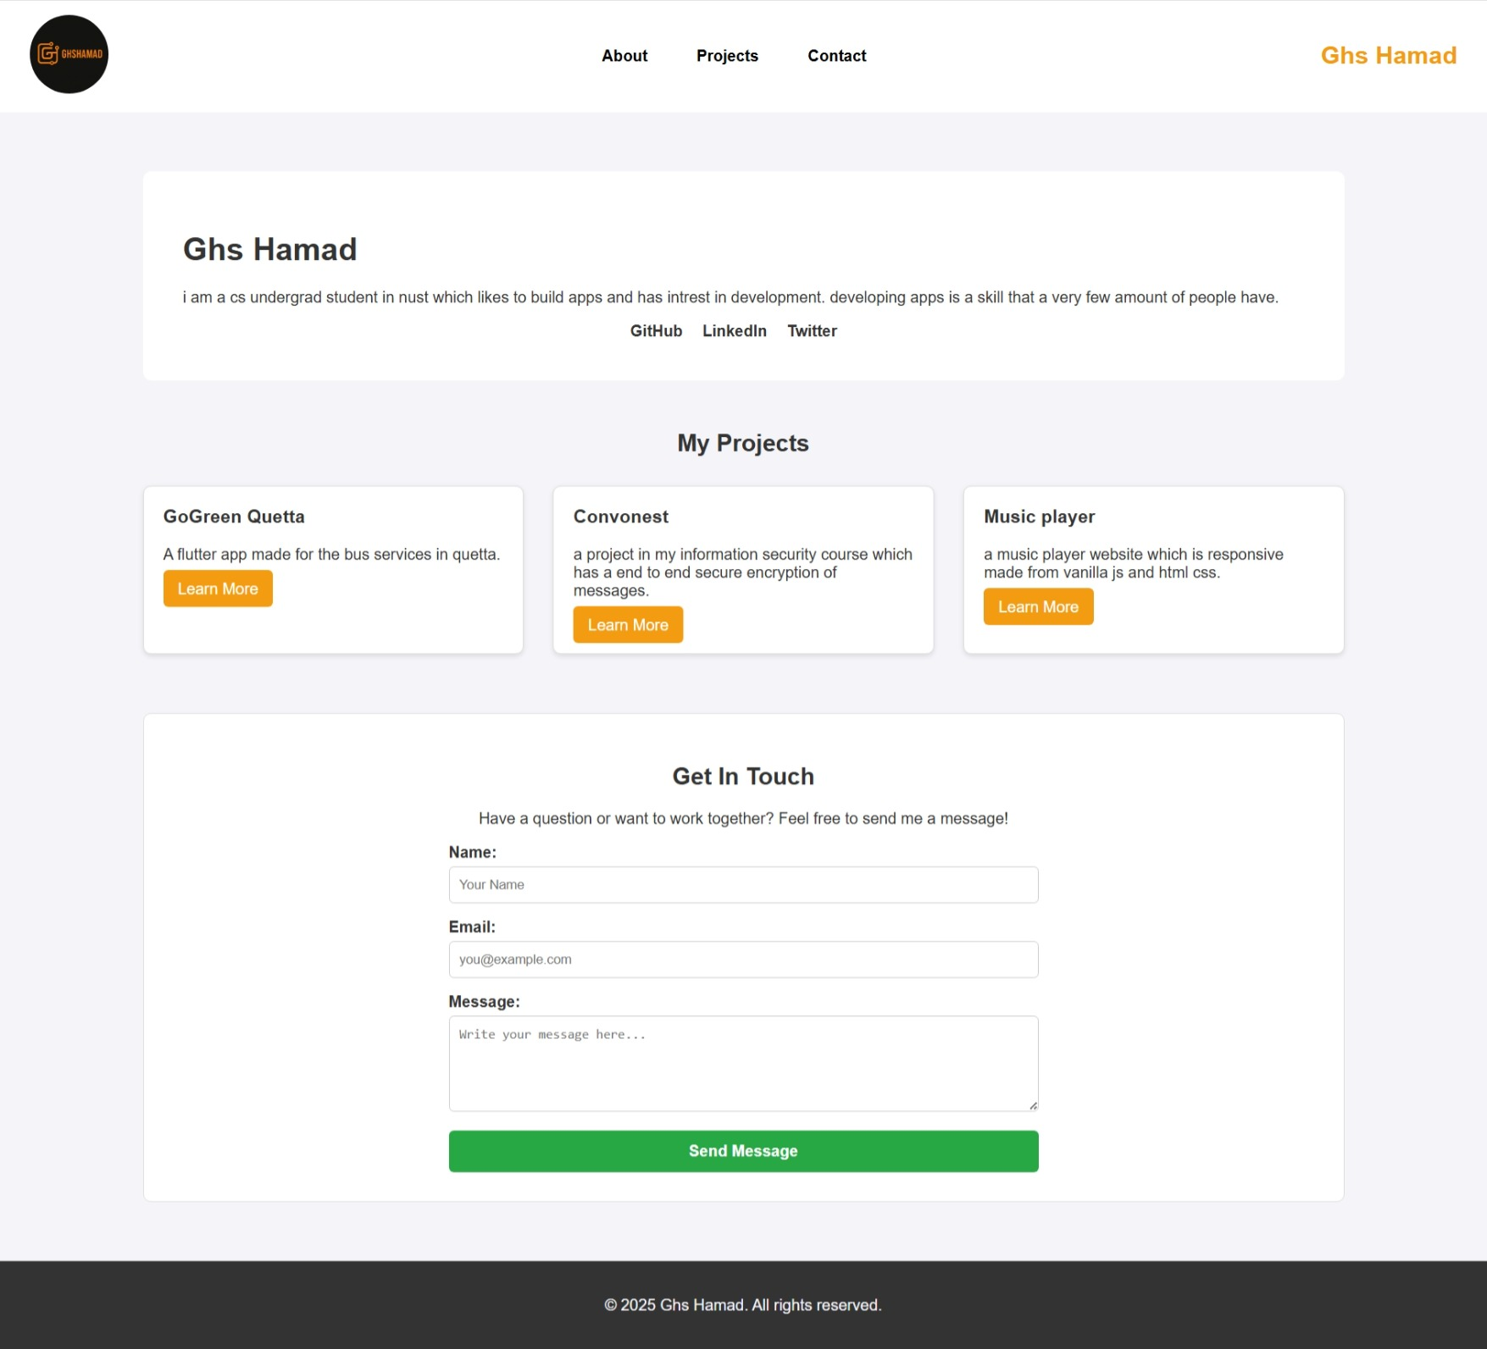

Mobile screenshot:

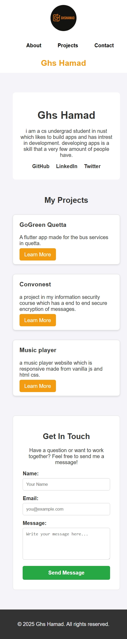

GitHub Link:
web-dev-labs/lab5 at main · GHSHamad312/web-dev-labs

